UNIT 1 - STEP 3 – Listening comprehension
1.Watch the beginning of the video and take notes about the setting.
Nature ? ………………………………………………………………………….
Place? ………………………………………………………………………….
Time ? ………………………………………………………………………….
Character? ………………………………………………………………………….
Topic ? ………………………………………………………………………….
So what is THE GOAL of the video ? ………………………………………………………………………………
2. Listen and write ONE PIECE OF INFORMATION about Hannah.
……………………………………………………………………………………………………………………………………………………….
3.SPEAK IN PAIRS - Look at the PARTS OF THE VIDEO and imagine what she’s going to say
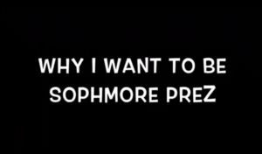 | She’s going to talk about her …  ………………………….. | -  -  - | AIDE  -mobilise des verbes d’action que tu connais
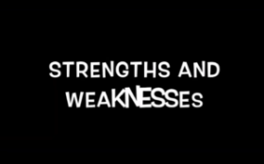 | She’s going to talk about her …  …………………………… | -  -  - | AIDE  -mobilise des adjectifs de qualités /défauts (cherche dans ton cahier si besoin)
4. Listen and check your answers √ Write more information in the grid
AIDE
-quand tu écoutes, repère les moments où elle utilise l’opérateur « to » et ce qu’elle dit juste après

5. Tu as terminé et que tu souhaites aller plus loin
dans tes apprentissages ?
Watch the 3rd part of the video and take notes
…………………………………………………………………………………………………………………………………………

7. Recap
If Hannah is elected Class President, she ………………………………………………………………………………………
…………………………………………………………………………………………………………………………………………………….…
She would love ……………………………………………………………………………………………………………………………….
She wants her class ………………………………………………………………………………………………………………………..
As a future class President, her mission is ……………………………………………………………………………………..
…………………………………………………………………………………………………………………………………………………..…...

7. GRAMMAR TOOLS ! Read the sentences
Hannah wants to be Class President.
She wants to organize events.
She wants her class to be closer and have fun.
She would love to be the voice of her class.
She is going to listen to people and try to find a compromise.

Ces phrases expriment ce que Hannah …………………………………………………………………………………………………
Hannah se projette donc dans le passé ? – le présent ? – l’avenir ?
Comment le sais-tu ? Entoure les expressions ou les mots qui te l’indiquent.
Pour exprimer ce que j’ai l’intention de faire, j’utilise « ……… » qui est un opérateur de visée.

Je retiens...
- Pour exprimer ce que j’ai l’intention de faire, j’utilise l’opérateur de visée « to » suivi d’une base verbale.
Sujet + want + to + base verbale
would like
be + going

- Pour exprimer ce que je veux que quelqu’un d’autre fasse :
Sujet + want + complément + to + base verbale
would like

