BEFORE YOU READ…
Exercise 1 – Match each word to its definition (souligne de la même couleur pour plus de visibilité)
Efficient (adj) The busiest time to travel.
pleasant (adj) To connect to a power source.
to plug in (verb) A drug or herb used to maintain health or treat a health issue.
to charge (verb) The plants on a farm that make food, fruit and vegetables.
sensor (noun) Nice.
crops (noun) To give something energy.
rush hour (noun) To reduce speed.
a medicine (noun) A device that measures something and responds to it.
breathe (verb) To take air into the lungs and expel it.
to slow down (verb) Quick, easy, and useful.
a traffic jam (noun) Information for drivers
a road sign Stationary or very slow-moving vehicles, caused by roadworks, an accident, or heavy congestion.

Exercise 2 – Look at the pictures on the document. Answer this question.
What is a smart city ? ……………………………………………………………………………………………………………………………………………………………………………………………………………….
Imagine 2 things that will be different in our daily life in 2025.
……………………………………………………………………………………………………………………………………………………………………………………………………………………………………………………

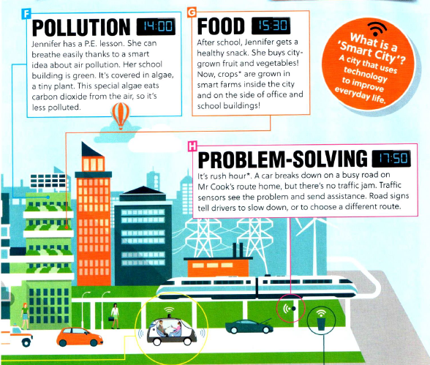
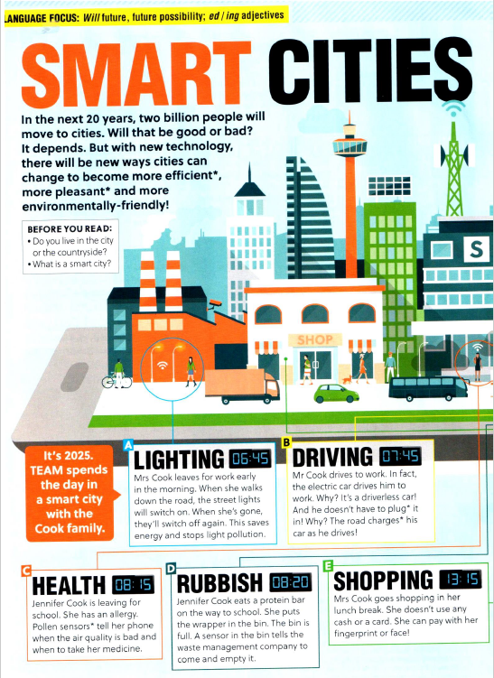

READING COMPREHENSION

Exercise – Read about the smart city. Write the correct letter in each box. Explain.
 | Letter? | Explain what will cause this.  What will be different in the future? (cite le texte)
1.This will stop litter and rats on the streets
2.This will save petrol.
3.This will limit traffic delays.
4.It will be easier and safer top pay for your lunch.
5.Food will be local and cheaper.
6.This will give the city cleaner, less polluted air.

DISCUSS

What are the best things about life in smart cities ?
………………………………………………………………………………………………………………………………………………………………………………………………………………………………………………………………………………………………………………………………………………………………………………………………………………………………………………………………………………………………………………………………………………………………………………………………………………………………………………………………………………………………………………………………………………………………

What are the worst things ?
………………………………………………………………………………………………………………………………………………………………………………………………………………………………………………………………………………………………………………………………………………………………………………………………………………………………………………………………………………………………………………………………………………………………………………………………………………………………………………………………………………………………………………………………………………………………

Would you like to live in a smart city ? Why ?
(Utilise l’expression de l’opinion, du goût et explique en t’appuyant du texte)
………………………………………………………………………………………………………………………………………………………………………………………………………………………………………………………………………………………………………………………………………………………………………………………………………………………………………………………………………………………………………………………………………………………………………………………………………………………………………………………………………………………………………………………………………………………………

