Dear students !
We are Brenda and Bill Drayton and we would like very much to be your NY host family.
We are a friendly family of 2 adults and a 15-year old boy. We have had 8 years experience in hosting students and guests from all over the world !
You will benefit from a warm, friendly, secure home with lots of interaction and conversation, or privacy if you prefer. You will feel encouraged to learn and grow in a quiet stable atmosphere.
Our large six bedroom individual home has lots of rooms for privacy, and a recreation room, with pool table, lounging area, a 64 wide-screen for movies, and video games, board games, arts and crafts and more ! We enjoy doing sports, travelling and art.
If you don’t bring your computer, there is a desk top, and a lap top for your use.
There is a great back yard with table, chairs, garden, cook-out area, and pool for hot summer days. The home is equipped with hi-speed wi-fi to make research and internet use exceptionnally fast.
Our fee will be $650 per month and you are welcome to use our separate kitchen for our guests If you prefer to cook your own meals.
The bedrooms are upstairs. You will have your own room here. It is equipped with twin beds, closet, desk, TV with complete movie, news, and sports package. You will find full towel and linen set. You have your own bathroom, like every bedroom here. Our washer and dryer are also available to you at no extra charge. No smoking inside the house. You must be home before 8 :30pm. No more noise after 9pm.
Our home is located in Queens NY. That’s about 20 minutes away from Manhattan.
We find hosting student to be a very rich rewarding way for our family to meet, interact and stay in touch with students the world over ! You will definitely have a great time !
You are sure to build friendships and contacts that can last a life-time.
Please feel free to contact us with any questions or concerns, we will be pleased to hear from you !
Cell 516-322-5083
I have included some photos. Just let us know and we will be happy to send as many as you would like !
Thank you,
Kind regards,
Bill & Brenda Drayton
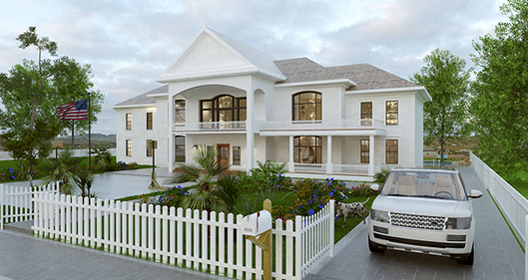
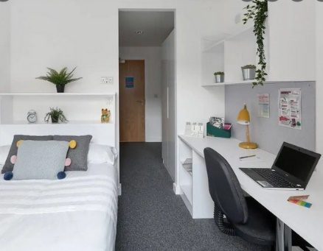

MY HOST FAMILY’S CONTACT INFORMATION

Name of my family .............................................................................................................................

Telephone: ..................................................................................................................

Address: ...................................................................................................................

City: ……………………………………………………………………………………….

Country :…………………………………………………………………………………………

Distance from NY centre: ……………………………………………………..….

MY HOST FAMILY’S HOUSE

Type of home :
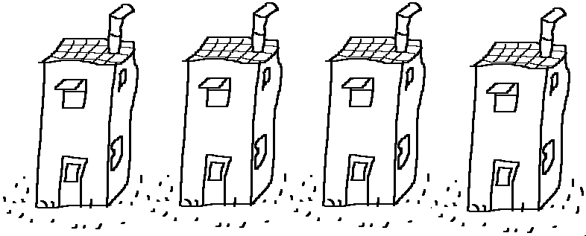  A detached house | 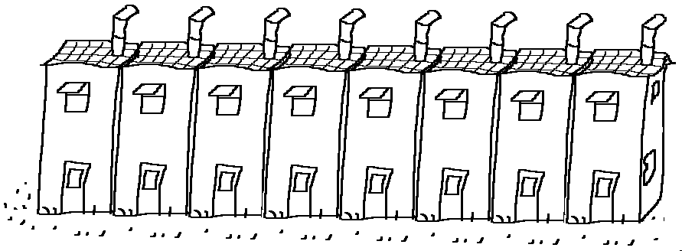  Terraced house | 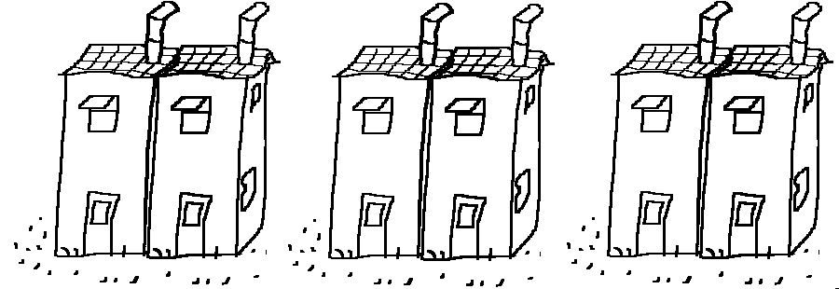  Semi detached house
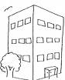  A block of flats | 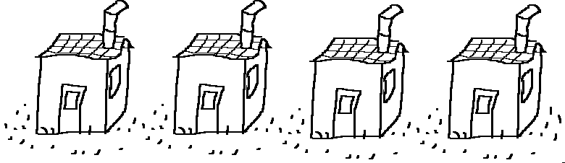  Bungalow | Is it small or big?  Is it old or modern?

Describe primary rooms and bedrooms

……………………………………………………………………………………………………………………….

Number of bathrooms ……………………………………………………………………………………………

List some equipment of the home

……………………………………………………………………………………………………………………….

Outside of the property: poor fair average above average excellent

Additional comments: ………………………………………………………………………………………………………………………….

Describe the student’s room

…………………………………………………………………………………………………………………….

……………………………………………………………………………………………………………………..

Will the student share a bedroom? Yes No If yes, with whom?
Any photographs of the host family’s home ?
Home exterior and grounds
Kitchen
Living Room
Family & Living Areas
Student’s Bedroom
Family Photo

Advantages of the house ? ……………………………………………………………………………………………

MY HOST FAMILY MEMBERS and ME

What is the primary language spoken in this home ? ……………………………………………………….

Is it a married couple / a single person? ………………………………………………………………………………………………

First names? ……………………………………………………………………………………………….

How old are they? ………………………………………………………………………………………………

Jobs? ………………………………………………………………………………………………

Where are they from? …………………………………………………………………………………................

Do they have children? ……………………………………………………….…………………………..………..

Children’s names? ……………………………………………………………………………………………...

How old are the children? ………………………………………………………………………………………..…...

Do they have pets? ………………………………………………………….…………………………….

Which family interests and activities are your family involved in? Check all that apply:
Science & Math Scouting Sports Performing Arts Fine Arts Travel Other

Why do they want to host a student ? ………………………………………………………………………………

……………………………………………………………………………………………………………………………

How long have they been hosting students ?

……………………………………………………………………………………………………………………………

How much does it cost ?

……………………………………………………………………………………………………………………………..

Rules :

It is not allowed to ………………………………………………/……………………………………………………..

You have to ……………………………………………………………………………………………………………..

REMEMBER THE WORDS
HOUSE
Individual / own room for students
Lots of rooms
A desk top
A lap top
A back yard
A cook-out area
A pool
The home/property is equipped with
Our home is located in
The fee is affordable /expensive ?
It is not not allowed to ..
It is allowed to …

FORMAL LETTER
Beginning of letter : Dear +name
End of letter : Kind regards

ADVANTAGES OF FAMILY
a warm secure and friendly home
lots of interaction and conversation
a very rewarding experience
some privacy
build friendships
Learn and grow in a quiet atmosphere
meet, interact and stay in touch with students
have a great time

SPEAK IN PAIRS
You want to go studying abroad. You are interested in the host family you have just found on the internet.
Your parents want to know more about this family and your project.
Imagine the conversation with your parents.

At least 2 questions per category

WRITE - You are interested to stay with the Drayton’s family, write an email to inform them:

Dear Mr and Mrs…,

I have just read your advert and I would really like to be your new host student.

My name is … I am from … and I am looking for a host family because…

You can trust me because people say that I am quite…
In my free time, …

My English level is …

Your house looks amazing because…

Your family matches my profile because …

I have a few questions to ask…

Could you …?
Would it be possible to ?
Would you mind + ING ?

I really hope you will choose me as your new host student. I’m looking forward to your reply.

(formule de politesse + signature)

